Phonics Lesson Ideas

Below you will find lesson ideas and activities that can be used to practice, introduce, or strengthen your students phonics skills.

ACTIVITY 1 - Cut out the pictures below and have the children tell you what they are. Remind them that they are magic e words. The e is silent and the vowel says its name.



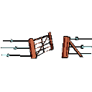
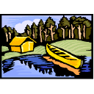


After the children guess what the pictures are, write the following Riddles on the board or give them the riddles to work on their own.

- I keep things out.
I keep things in.
I rhyme with date.
I am a __________

- You can swim in me.
I rhyme with snake.
I am a _________

- I have eyes. I have a mouth.
I rhyme with place.
I am your __________

- You can put me on.
I rhyme with late.
I am a ____________

- You can run in me.
I rhyme with lace.
I am a _________

ACTIVITY 2 – Long Vowel Word, Long Vowel Word, Goose!

First say a word with a long vowel phonogram and have the children make a quick list of words that rhyme with the word. Erase the list from the board and pick a child to be it. Then have the child you pick walk around the the circle touching the children’s heads and saying a word that rhymes with the word you brainstormed. When the child can no longer think of a rhyme word he touches the next person’s head and says goose. The goose chases the child around the circle. If the person who was it gets back to the Goose’s spot before being tagged, he or she is safe and the goose is it. If not the child must try again with another word.

ACTIVITY 3 - Cut out the cards below and give one to each student in your class…
gold
hold
told
mold
fold
wild
child
mild
find
mind
behind
kind
mail
tail
nail
pail
rail
sail
ate
date
late
slate
nice
twice
mice
price
spice
beet
meet
feet
sheet
greet
After giving each child one of the cards explain to your class that when you say goo, they are to say their word aloud quietly as they walk around the room, listening for other players saying words that rhyme with theirs. When they find other players that have a word that rhymes with their words they are to stay together and look for other players that rhyme. After a few minutes, see if the members have found one another!

ACTIVITY 4 – Tell children to beep like a jeep when they hear words that rhyme with jeep and beep… Say a variety of words and include ee words.
ACTIVITIE 5 – Cut ovals from colored paper, and give several to each child. Then tell the students to draw a snakes face on one oval and write long a words on the other ovals. Have the students glue the ovals together to form a SLINKY SNAKE.

Activity Six – Cut out the bee below and place him on a stick. Then cut out the flowers…
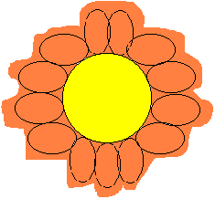
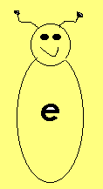

After the flowers and the bee are cut out program the flowers with the words cap, tap, fin, hid, hop, cut, and cub. Move the bee from flower to flower so that each time it is at the end of the word. As you move the bee have the students read the new word. Have the students write sentences using the new words…

Activity Seven - Bring is a sand pail and place a nail, paint, mail, a chain, and a braid inside the pail. Show the pail and the objects in the pail to the class. Write the name of the objects on the board.

Next write the words hail, jail, rail, sail, tail, bait, pain, and maid on slips of paper. Place the slips in the pail. Have the students pull the words out of the pail and say a sentence with the ai word in it. Have the sentence maker pick a student to guess the ai word in his/her sentence. Repeat.

Activity Eight – Write hay, day, jay, clay, bay, gray, play, say, may clay, crayon, and pay on the board. Then read the following clues one at a time. Have a student circle the correct answer on the board.
Horses eat this.
This is made up of 24 hours.
This is a bird.
This is a body of water.
This is a color.
You do this at recess.
You can make this into a ball.
You use this to color a picture.
You do this when you buy something.

